1. Exercises- Propositional Logic

Exercise 1.1
Check the following properties for (’nor’), (’nand’) and (’xor’) connectives using the truth table method.
- associativity of ’’ connective: 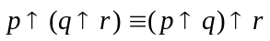;
- associativity of ’’ connective: 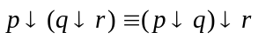;
- associativity of ’’ connective: 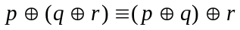;
- distribution of ’’ connective over ’’ connective:
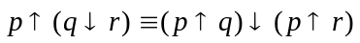;
- distribution of ’’ connective over ’’ connective:
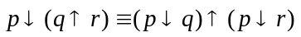;
- De Morgan’s laws for ’’ and ’’:
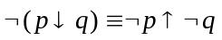 and 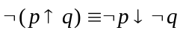;
- 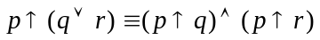 and 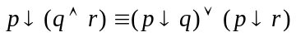.
- 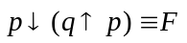 and 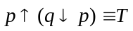;
Exercise 1.2.
Using the truth table method decide what kind of formula (consistent, inconsistent, tautology, contingent) is 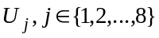. Write all the models and anti-models of .
- 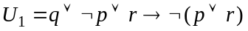; | - 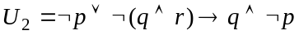;
- 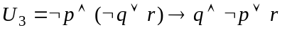; | - 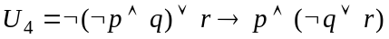;
- 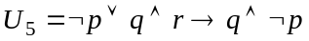; | - 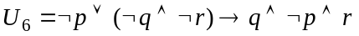;
- 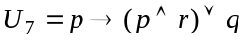; | - 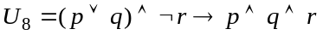.
Exercise 1.3.
Using the truth table method, check whether the following logical consequences hold:

- 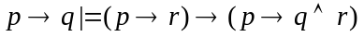; | - 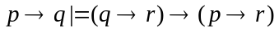;
- ; | - ;
- 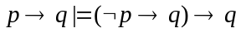; | - 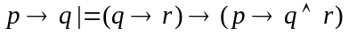;
- 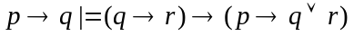; | - .

Exercise 1.4.
Prove that the following formulas are tautologies using the truth table method.

- the left-distribution of ’’ over ’’: ;
- the permutation of the premises law: 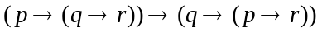;
- the reunion of the premises law: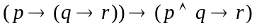;
- the separation of the premises law: 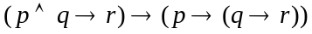;
- the left-distribution of ’’ over ’’: ;
- the left-distribution of ’’ over ’’:;
- the left-distribution of ’’ over ’’:;
- the left-distribution of ’’ over ’’:.
Exercise 1.5.
Transform the formulas into their equivalent conjunctive and disjunctive normal forms. Using one of these forms prove that are valid formulas in propositional logic.
- ;
- ;
- 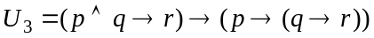;
- ;
- ;
- ;
- ;
- .
Exercise 1.6.
Using the appropriate normal form write all the models of the following formulas:

- 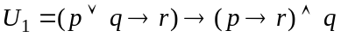;
- ;
- 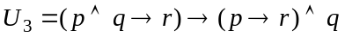;
- 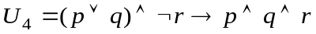;
- ;
- 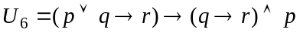;
- 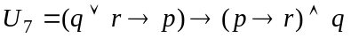;
- 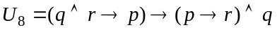.
Exercise 1.7.
Using the appropriate normal form, prove that the following formulas are inconsistent:
- ;
- 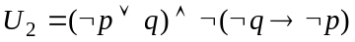;
- ;
- ;
- ;
- 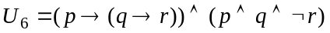;
- ;
- .
Exercise 1.8.
Write all the anti-models of the following formulas using CNF.
- 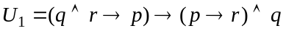;
- 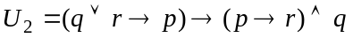;
- 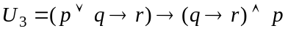;
- ;
- 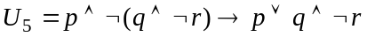;
- 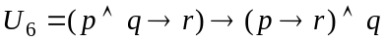;
- ;
- 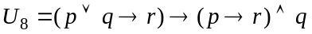.
Exercise 1.9.
Using the definition of deduction, prove the following deductions:

- 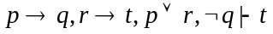; | - 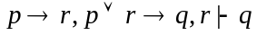;
- 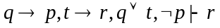; | - 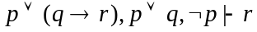;
- 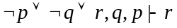; | - 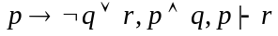;
- 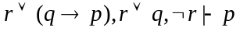; | - 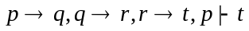.

Exercise 1.10.
Prove the following theorems using the theorem of deduction and its reverse.

- ;
- ;
- 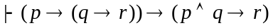;
- 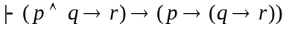;
- ;
- ;
- ;
- .

Exercise 1.11.
Using the theorem of deduction and its reverse prove that:

- ;
- ;
- ;
- ;
- ;
- ;
- ;
- .

Exercise 1.12:


